Hello to everyone!!

We are students from KL University, Vijayawada pursuing B-Tech II Nd year in the stream of CSE. This Article gives a brief about our Skill Development Project (SDP-23) project i.e.., movie or tv recommendation system. We conducted some surveys and research to get some initial about our  business system.

**TEAM MEMBERS:**1.polisetty siva ram Charan-2200032341  
  
2.bollimuntha mukhesh -2200032340  
  
3.vippala Charan reddy-2200032605

**Project Name:**

MOVIE OR TV RECOMMENDATION SYSTEM

**MENTOR NAME:**

A.THANUJA MAM

**INTRODUCTION**

**Introduction to movie or tv recommendation system**

In today's fast-paced digital landscape, the abundance of movies and TV shows can be both a blessing and a challenge. How do you choose what to watch from an overwhelming sea of options? This is where the magic of movie and TV recommendation systems comes into play. These ingenious technological solutions are designed to simplify your decision-making process and enhance your entertainment experience.

Creating a movie or TV show recommendation system using the MERN stack (MongoDB, Express.js, React.js, and Node.js) is a fantastic way to combine modern web development technologies with data-driven insights. This system can provide users with personalized suggestions for movies and TV shows based on their preferences and viewing history. This article takes you on a journey into the world of recommendation systems.

**ANALYTICS**

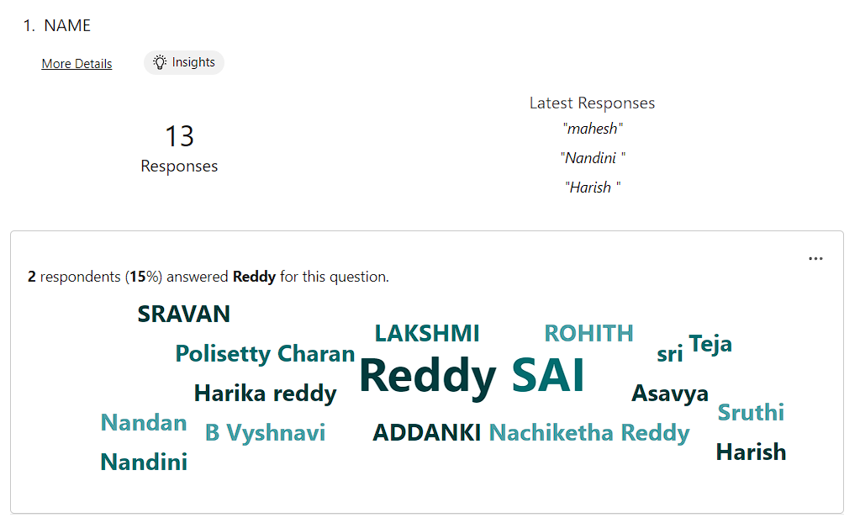

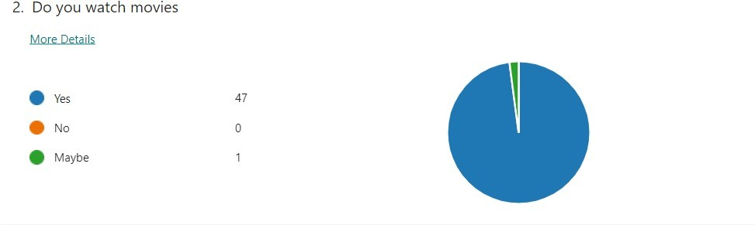

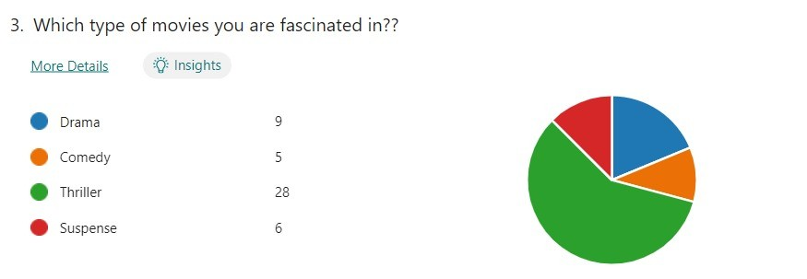

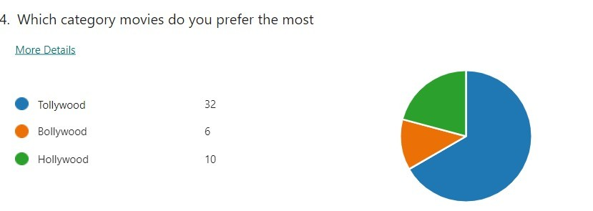

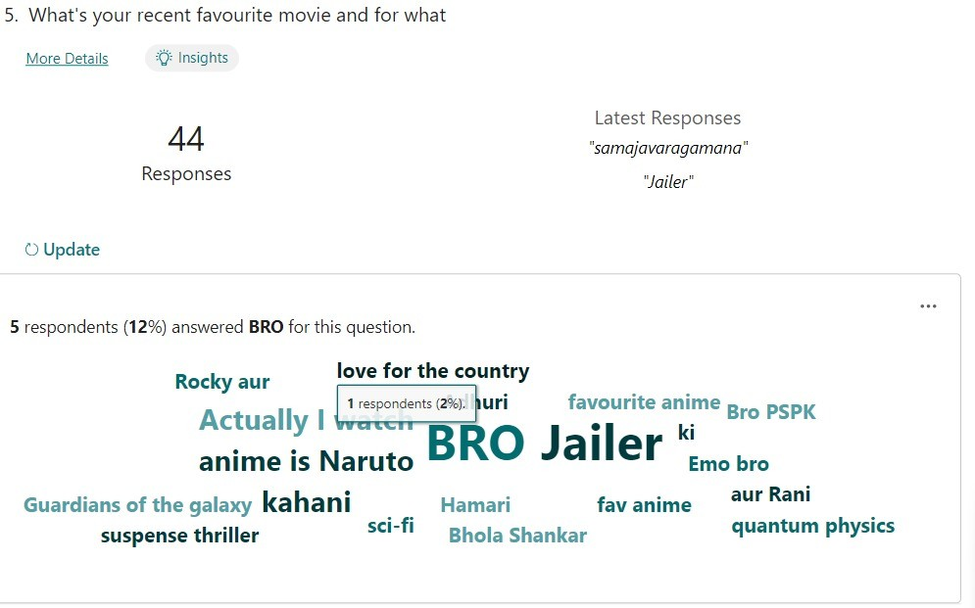

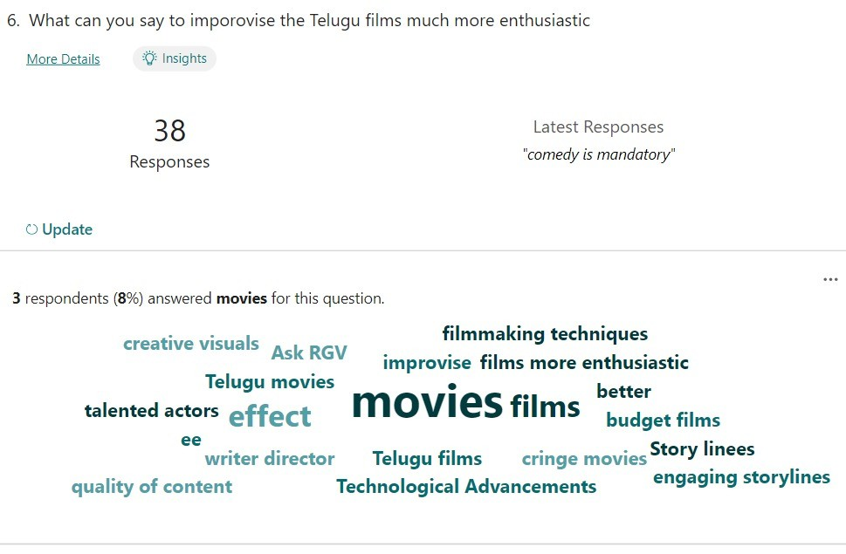

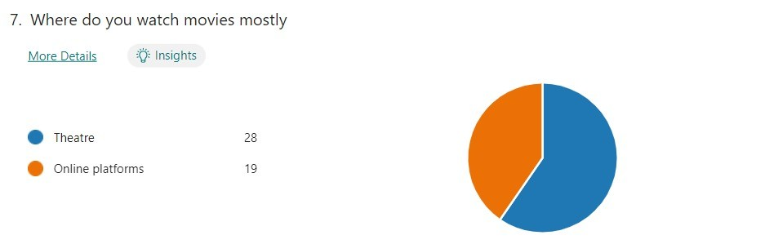

**JOURNEY MAP**

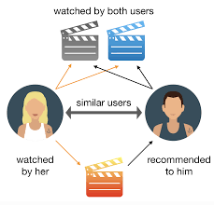

**EMPATHY MAP**

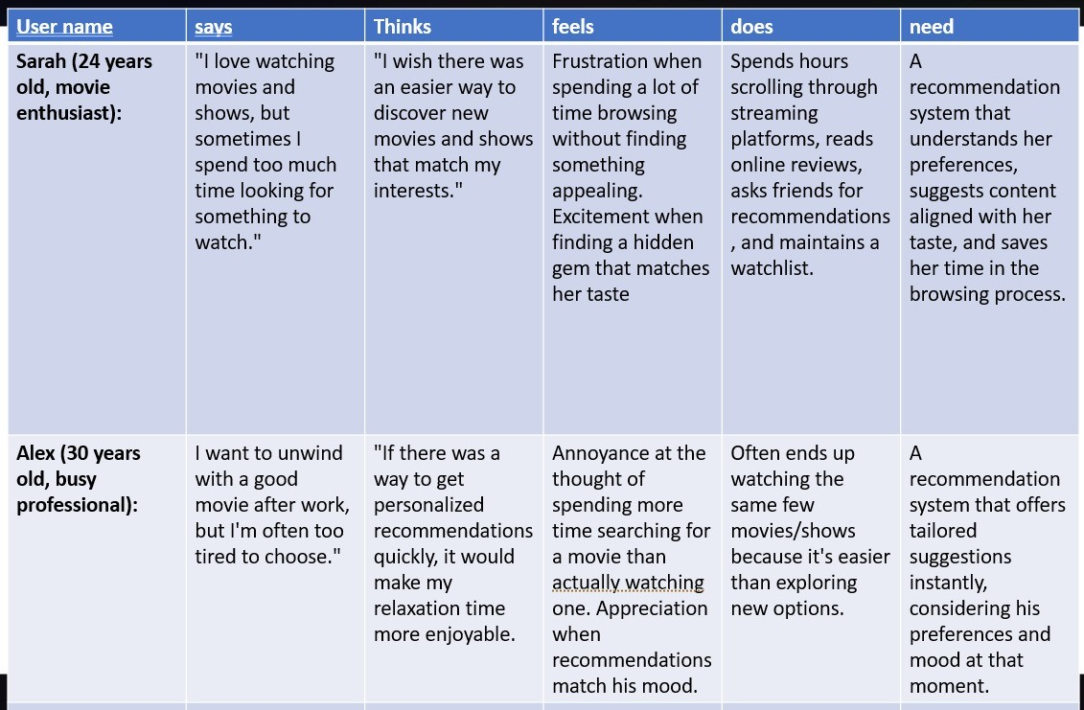

**PERSONA**

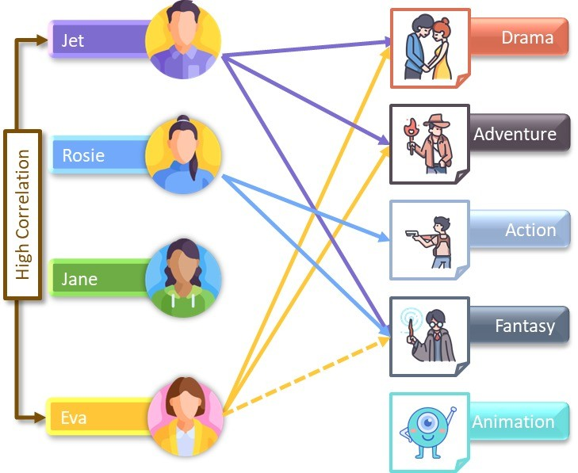

**Components**

Creating an effective movie or TV show recommendation system involves various components working together to deliver accurate and relevant suggestions to users. Here are the key components that contribute to the functionality of such a system:

**MongoDB:**

MongoDB is a NoSQL database that will store the data required for your recommendation system. You'll create collections to store user profiles, movie/show data, user interactions (like ratings and watch history), and possibly genre information.

**Express.js***:*

Express.js is a backend framework that will handle routing, API creation, and server-side logic. You'll create routes to handle user authentication, data retrieval, and recommendation logic.

**React.js:**

React.js is a frontend library that enables you to create interactive and dynamic user interfaces. You'll build components for user registration, login, profile management, and displaying recommended movies/shows.

**Node.js:**

Node.js is the runtime environment that will power your backend logic. You'll write server-side code using Node.js to handle user requests, perform data processing, and integrate with MongoDB.

**User Authentication:**

Implement user authentication using libraries like Passport.js or JWT. Users should be able to register, log in, and manage their accounts securely.

**User Profile:**

**User Preferences:** Capturing user preferences through interactions, ratings, likes, and watch history.

**Content Database:**

* **User Ratings and Reviews:** Aggregated user feedback that helps in assessing content quality.**Data Preprocessing:**
* **Data Cleaning:** Ensuring the data is accurate, complete, and consistent.
* **Feature Engineering:** Creating relevant features or attributes that can improve recommendation accuracy .**Real-time Data Processing:**
* **Scalability:** Handling a large number of users and items efficiently.
* **Speed:** Processing user interactions in real-time to provide instant recommendations.
* **User Interaction and Feedback***:* Allow users to rate content, mark items as watched, add to watchlists, and update their preferences. User interactions will help refine recommendations over time.
* **User Feedback and Updates:** Collect user feedback to make improvements. You might refine algorithms, add new features, or enhance the user interface based on user input. By combining the MERN stack with recommendation algorithms and user interaction, you can create a powerful movie or TV recommendation system that offers a personalized entertainment experience for  users.

**USERS**

Casual Viewers

Genre Enthusiasts

Binge-Watchers

Family-Oriented Viewers

Critics and Film Buffs

Social Viewers

**CONCLUSION:**

* In conclusion, movie and TV show recommendation systems play a crucial role in helping users discover content they might enjoy in the vast landscape of entertainment options available today. These systems use various techniques to analyze user behavior and item characteristics, aiming to provide personalized and engaging suggestions.
* Building a movie or TV recommendation system using the MERN stack involves combining modern web development components with data-driven insights to create a personalized entertainment experience for users .